**Title: Namaq Café**

**CIT112**

**Mr. Tariq Aziz**

**27/11/2024**

**Ahmed AL Ghamdi: The leader / CSS**

**Abdulrahman AL Rashidi: JavaScript**

**Ahmed Belhaj: HTML**

**Aims and objectives**

The focus for this group project is to ensure that our coding and styling skills are good and applying images and use them in the correct way to make the web pages simple to do and to use.

**Lap achievement**

In this group project, we were able to Complete a website that similar to Namaq Café original website, it contains images, each one of them is organized as well as we have developed our knowledge with HTML, CSS and JavaScript.

**Self-learning**

We was able to find better learning tools in the CIT112 book, which helped us learn what to use at this project. From this book we have gained the skills and learned what we need to make an organized website with a better style using images, it really helped us to know how to do and design a website with good styling.

**Conclusion**

Overall, we are successfully able to complete a website pages with images, background image, and fonts in just a simple tags with a different styling methods in a good way.

**References**

CIT 112 BOOK.

**GitHub Link**

<https://github.com/ahmedALghamdi351/CIT-112-Project>

**Main page:**

<!DOCTYPE html>

<html lang="en">

<head>

<title>Namaq Cafe</title>

<meta charset="UTF-8">

<style>

body, html {

  height: 100%;

  margin: 0;

  font-family: "Inconsolata", sans-serif;

  background-color: #f8f8f8;

  text-align: center;

}

.a {

  position: fixed;

  width: 100%;

  z-index: 10;

  background:rgb(63, 76, 50 );

  padding: 10px 0;

  box-shadow: 0 4px 6px rgba(0, 0, 0, 0.1);

}

.b {

  display: flex;

  justify-content: center;

  align-items: center;

}

.c{

  padding: 10px 20px;

  font-size: 16px;

  color: #fff;

  background: transparent;

  border: none;

  transition: all .5s ease;

  text-decoration: none;

}

.c:hover {

  background-color: #555;

  border-radius: 5px;

}

@media (max-width: 768px) {

  .c{

    font-size: 14px;

    padding: 8px 16px;

  }

}

.d {

  background-image: url("w2.jpg");

  background-size: cover;

  background-position: center;

  height: 75%;

  position: relative;

}

.f {

  position: absolute;

  top: 50%;

  left: 50%;

  transform: translate(-50%, -50%);

  text-align: center;

}

.g {

  font-size: 80px;

  color: #fff;

  text-shadow: 2px 2px 8px rgba(0, 0, 0, 0.5);

  font-weight: bold;

}

#where img {

  border-radius: 10px;

}

#about {

  padding: 50px 20px;

  background: #fff;

}

#about img {

  max-width: 100%;

  border-radius: 10px;

  margin-top: 20px;

  box-shadow: 0 4px 8px rgba(0, 0, 0, 0.1);

}

h5 {

  font-size: 24px;

  margin-bottom: 10px;

  color: #444;

}

form {

  margin: 20px auto;

  max-width: 500px;

}

form input {

  width: 100%;

  padding: 12px;

  margin-bottom: 20px;

  border: 1px solid rgb(63, 76, 50 );;

  font-size: 16px;

}

form button {

  background: #333;

  color: white;

  border: none;

  cursor: pointer;

}

form button:hover {

  background: #555;

}

@media (max-width: 768px) {

  .g {

    font-size: 60px;

  }

}

footer{

  color: white;

  background: rgb(38, 37, 37);

  font-family: "Gill Sans", sans-serif;

  padding: 1%;

}

.container {

  font-family: "Gill Sans", sans-serif;

}

.z {

  text-decoration: none;

  color: black;

}

.z:hover {

  background: #827c7c;

  padding: 1%;

  border-radius: 5px;

}

.x {

  text-decoration: none;

}

.x:hover {

  background: #827c7c;

  padding: 1%;

  border-radius: 5px;

}

#hag {

  display: inline-block;

}

#rim image{

  float: right;

}

form button {

  width: 105%;

  padding: 12px;

  margin-bottom: 20px;

  border: 1px solid rgb(63, 76, 50 );;

  font-size: 16px;

}

</style>

</head>

<body>

<div class="a">

  <div class="b">

    <a href="#" class="c">HOME</a>

    <a href="#about" class="c">ABOUT</a>

    <a href="menu.html" target="_blank"  class="c">MENU</a>

    <a href="#where" class="c">WHERE</a>

    <a href="login.html" class="c">LOGIN</a>

  </div>

</div>

<header class="d">

  <div class="f">

    <span class="g">the<br>Cafe</span>

  </div>

</header>

<div class="container">

<div id="about">

  <h5>ABOUT THE CAFE</h5>

  <p>Namaq Cafe is a specialty coffee shop chain in Saudi Arabia known for its quality beverages and unique interior design...</p>

  <img src="e11.jpg" alt="e11" style="width:100%;max-width:1000px" >

  <p><strong>Opening hours:</strong> everyday from 6am to 5pm.</p>

  <p>

  <a href="https://shorturl.at/15ixi" class="z" target="_blank">our Location</a>

   </p>

</div>

</div>

<div id="where">

  <h5>WHERE TO FIND US</h5>

  <img src="e22.png" alt="e22"

  width="800px"

  >

  <p>We offer full-service catering for any event, large or small. We understand your needs and we will cater the food to satisfy the biggerst criteria of them all, both look and taste.</p>

   <p> Reserve a table, ask for today's special or just send us a message:</p>

  <form action="confirmation.html">

    <input type="text" placeholder="Name">

    <input type="number" placeholder="How many people">

    <input type="text" placeholder="Message" >

    <button type="submit">SEND MESSAGE</button>

  </form>

</div>

<footer>

  <div >

    <div >

      <p><a href="Who we are.html" class="x" target="_blank" style="color: #fff;">Who we are</a></p>

    </div>

  </div>

  <div >

    <p>Copyright ; 2024 NAMQ CAFFEE</p>

  </div>

  <p id="hag"><a #link href="https://www.instagram.com/namq_cafe/" target="_blank"><img src="v1.jpg" alt="v1" width="25px" height="25px" id="rim"></a></p>

<pid="hfg"><a #link href="https://x.com/namq_cafe/status/1678702069677522945?mx=2" target="_blank"><img src="v2.png" alt="v2" width="25px" height="25px" id="rim">

</a>

<pid="fds"><a #link href="https://www.facebook.com/people/namq_cafe/100065082097105/" target="_blank"><img src="v3.png" alt="v3" width="25px" height="25px" id="rim">

</a></p>

</footer>

</div>

</body>

</html>

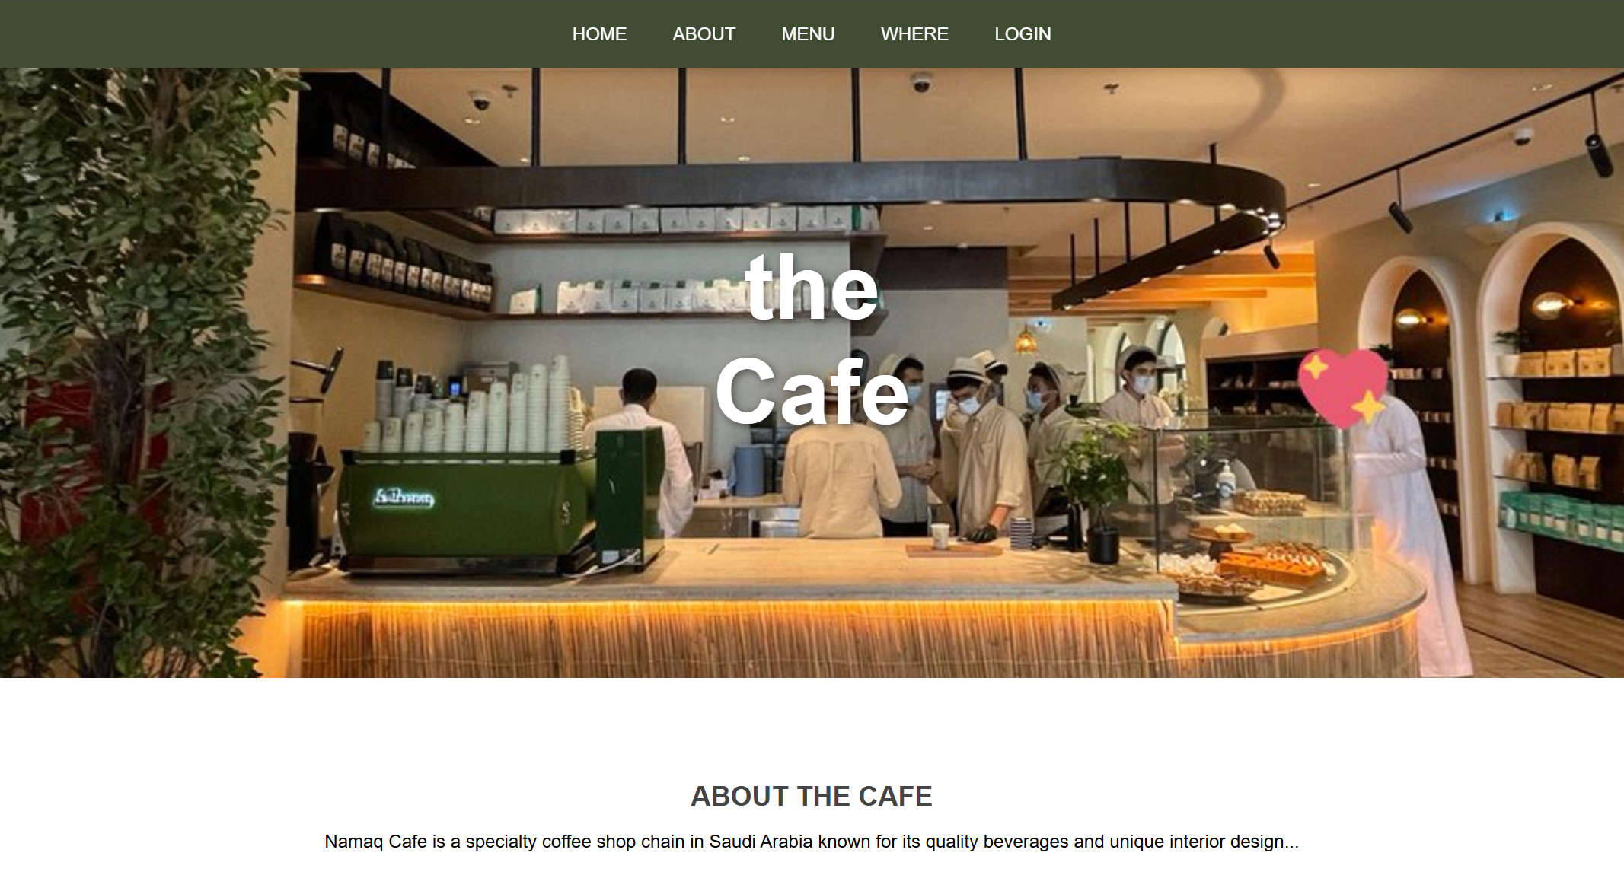

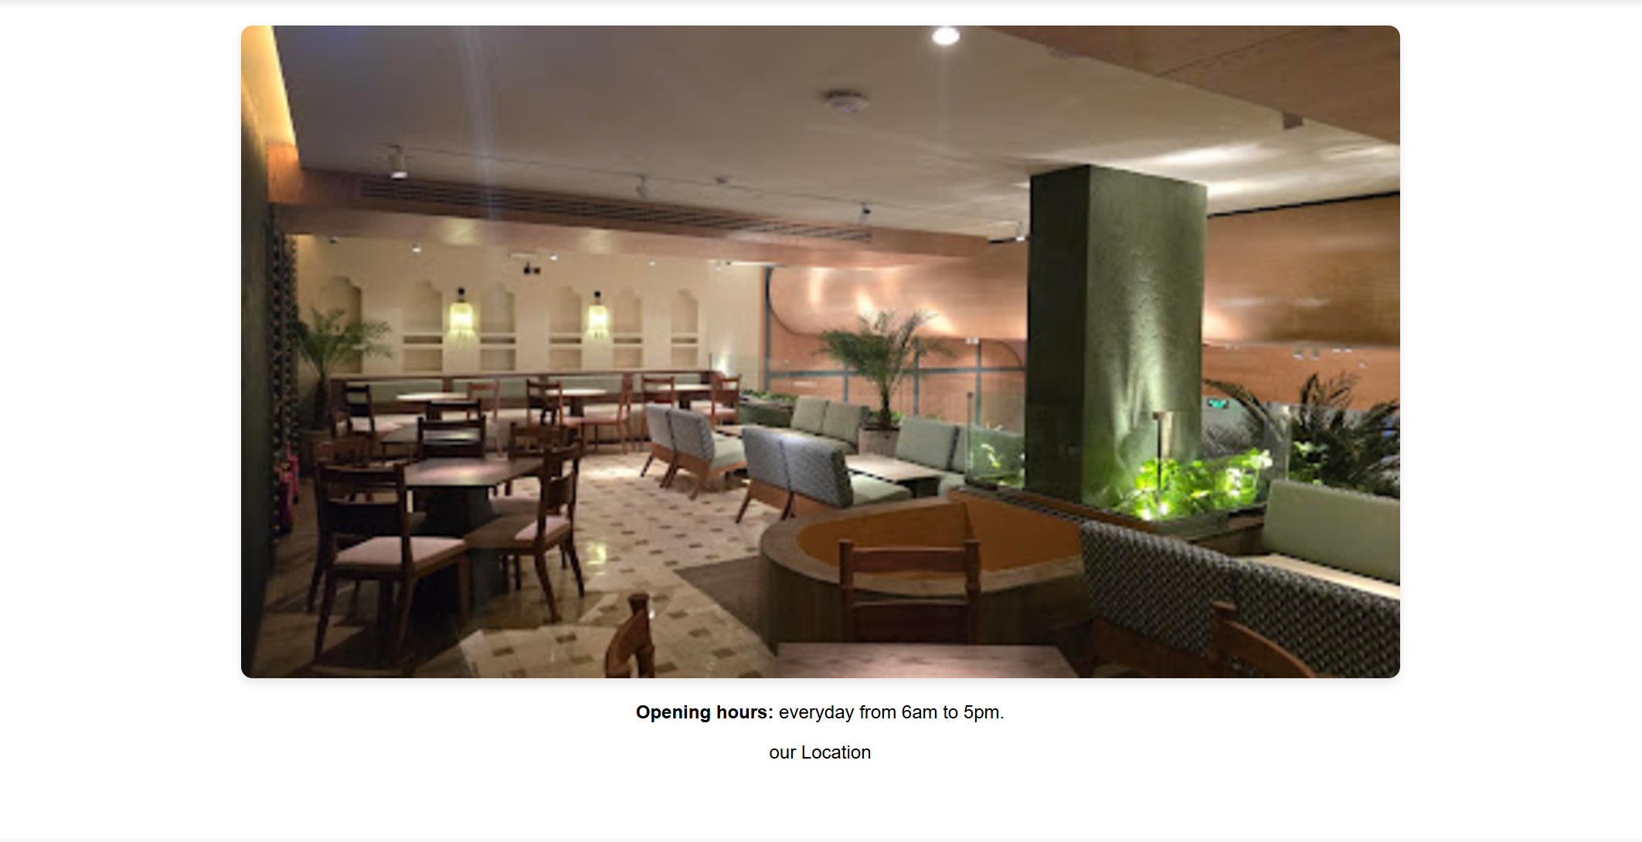

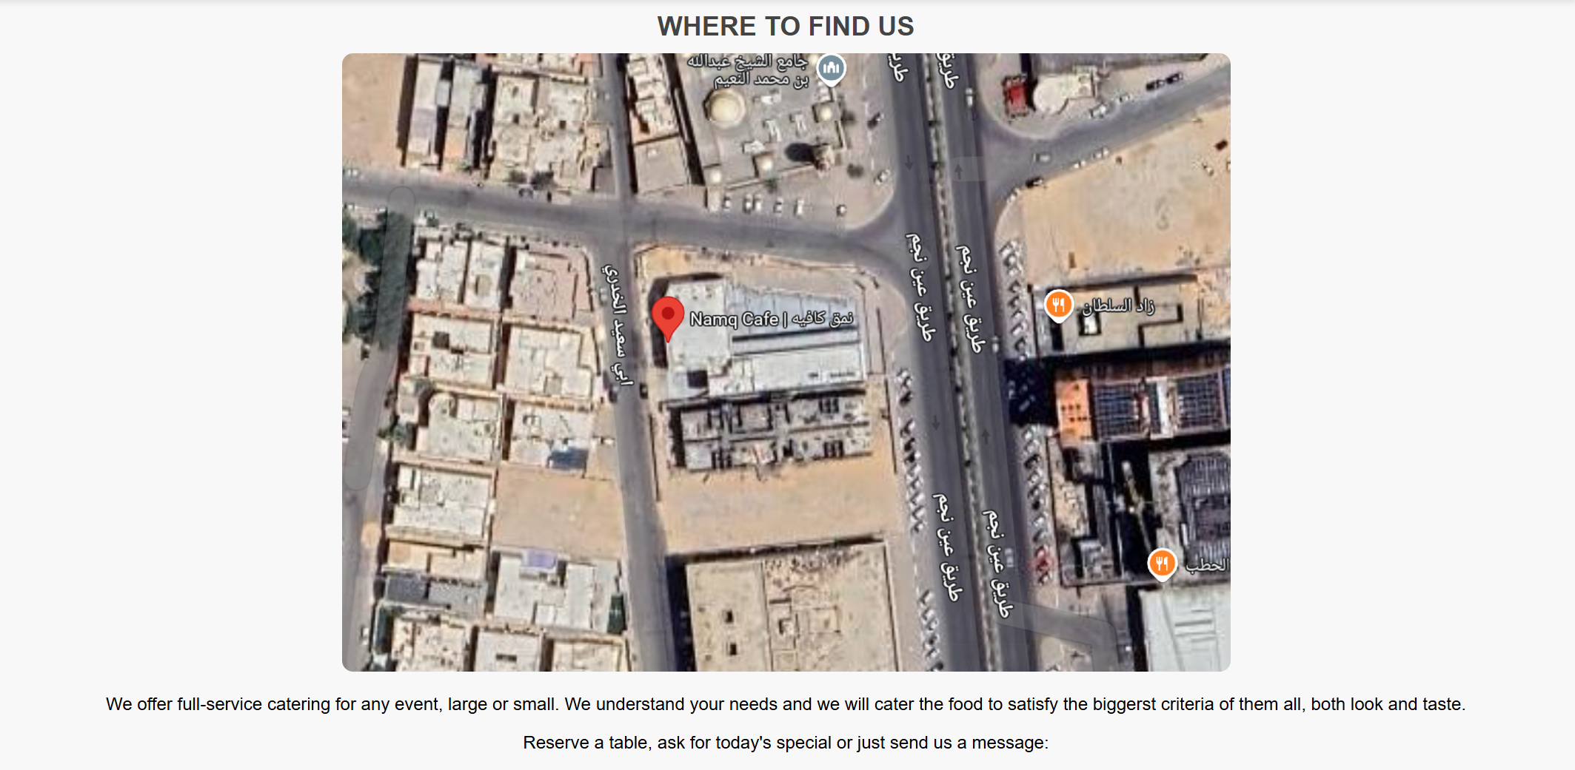

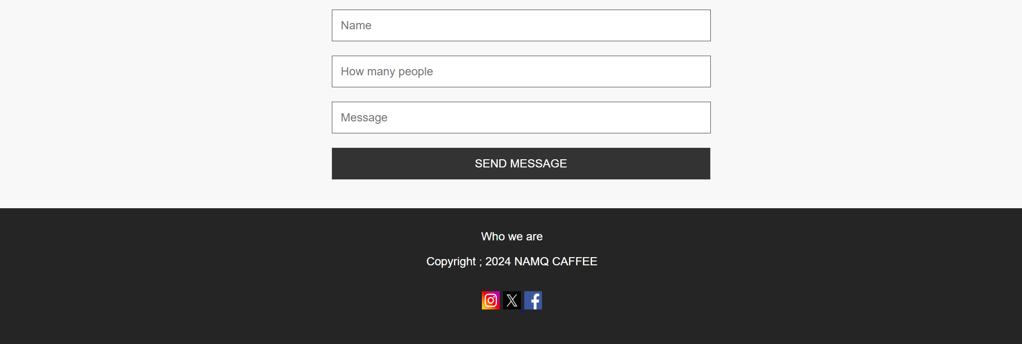

**Login:**

<!DOCTYPE html>

<html>

<head>

  <title>Login Page</title>

  <meta charset="UTF-8">

  <style>

    body, html {

      margin: 0;

      padding: 0;

      height: 100%;

      font-family: Arial, sans-serif;

      background: #d2cfcc;

      color: #333;

    }

    .a {

      margin-top: 10%;

      text-align: center;

      color: white;

    }

    .b {

      width: 100%;

      padding: 12px;

      margin-bottom: 15px;

      border: 1px solid #ccc;

      border-radius: 5px;

    }

    .b:focus {

      border-color: rgb(63, 76, 50 );

      box-shadow: 0 0 5px rgb(63, 76, 50 );

      outline: none;

    }

    .d {

      width: 105%;

      padding: 12px;

      background-color: rgb(63, 76, 50 );

      color: white;

      border: none;

      border-radius: 5px;

      font-size: 16px;

      cursor: pointer;

      transition: background-color 0.3s ease;

    }

    .d:hover {

      background-color:rgb(63, 76, 50 );

    }

    .q a {

      color: rgb(63, 76, 50 );

      text-decoration: none;

      font-weight: bold;

    }

    .q a:hover {

      color:rgb(63, 76, 50 );

    }

    @media (max-width: 768px) {

      .a {

        margin-top: 20%;

      }

    }

    .z {

      color: black;

    }

  </style>

</head>

<body>

<div class="a">

  <h2>Login</h2>

</div>

<div  style="max-width: 500px; margin: auto;">

  <form id="e">

    <label for="email"><b>Email*</b></label>

    <input class="b" type="email" id="email" name="email" placeholder="Enter your email">

    <label for="password"><b>Password*</b></label>

    <input class="b" type="password" id="password" name="password" placeholder="Enter your password">

    <p><INPUT type="checkbox" name="login" id="loged"> Stay logged in</p>

    <button class="d q" type="submit">Login</button>

  </form>

  <p class="z q">Don't have an account? <a href="#">Sign up</a></p>

</div>

<script>

  document.getElementById("e").addEventListener("submit", function(event) {

    event.preventDefault();

    const email = document.getElementById("email").value;

    const password = document.getElementById("password").value;

    if (email && password) {

      alert("Login successful!");

      window.location.href = "main page.html";

    } else {

      alert("Please fill in both fields.");

    }

    });

</script>

</body>

</html>

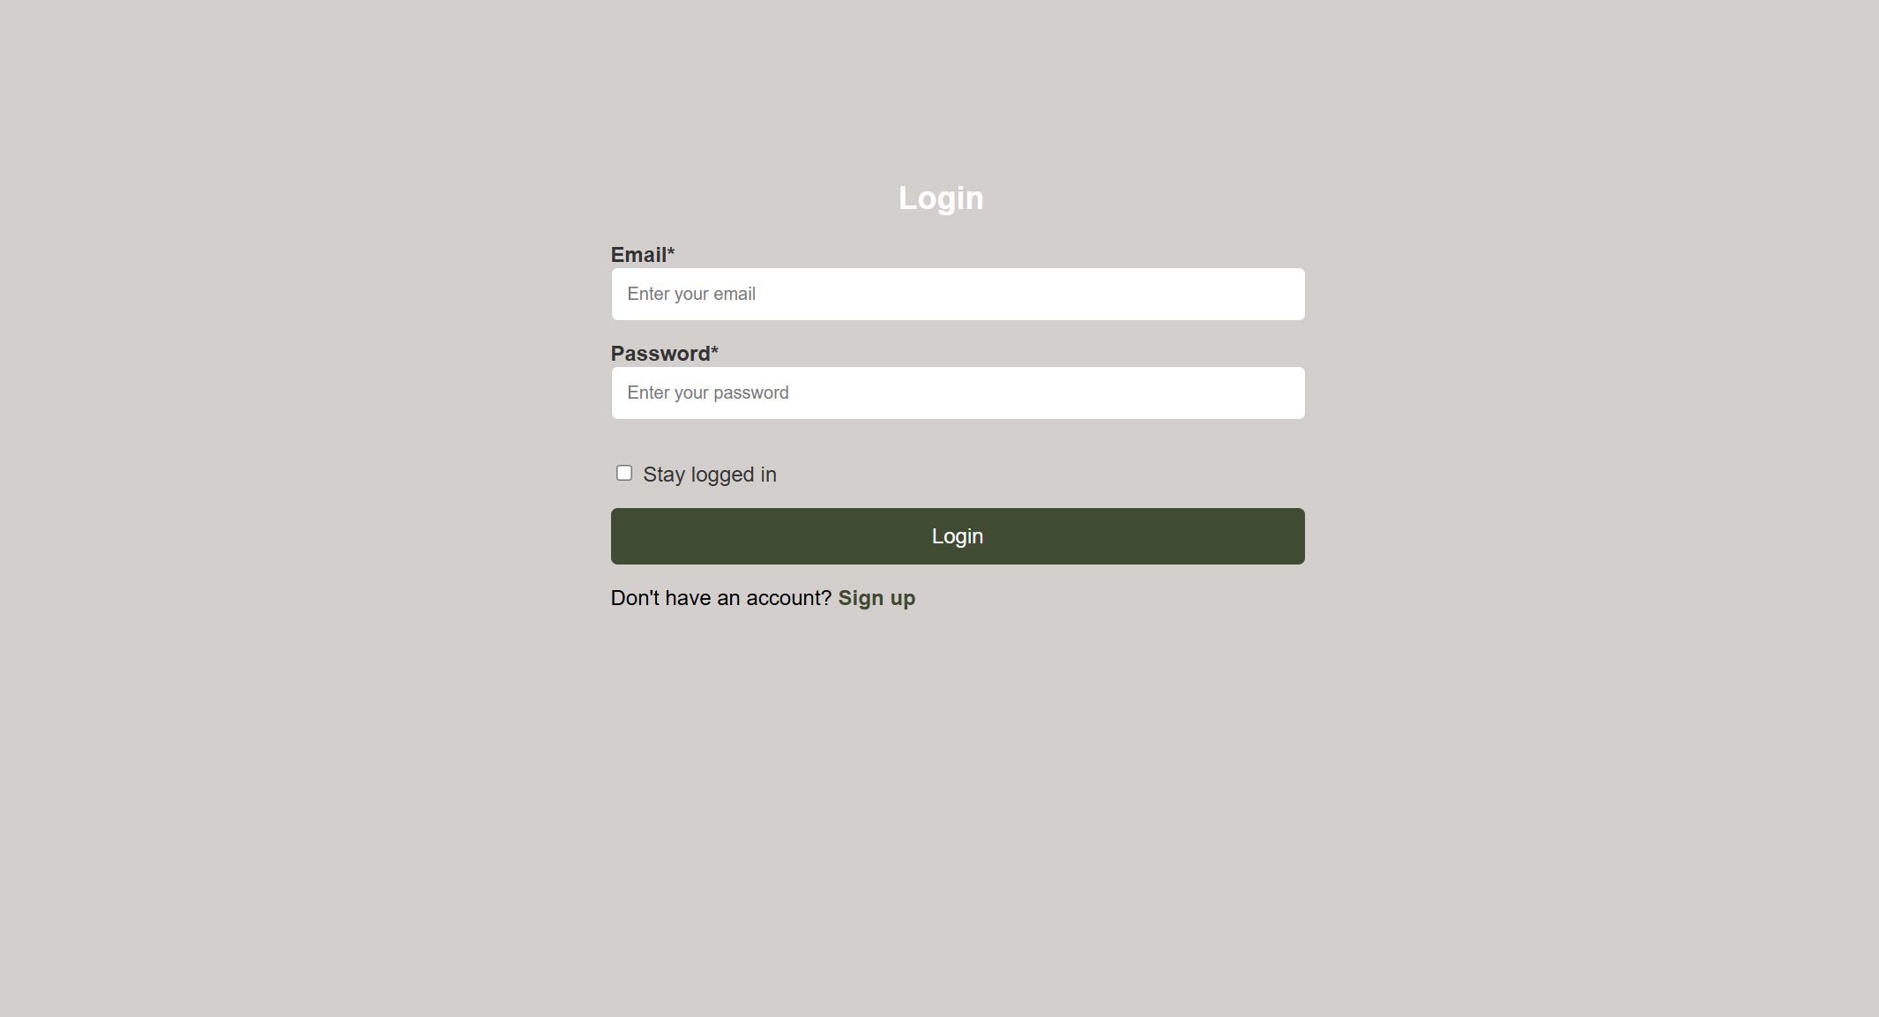

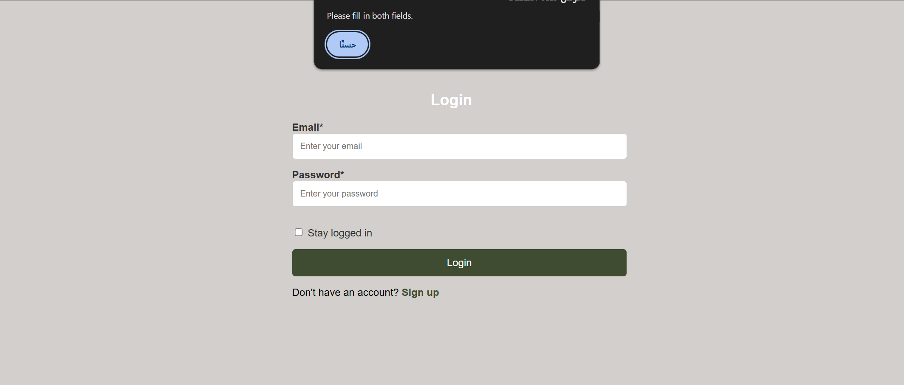

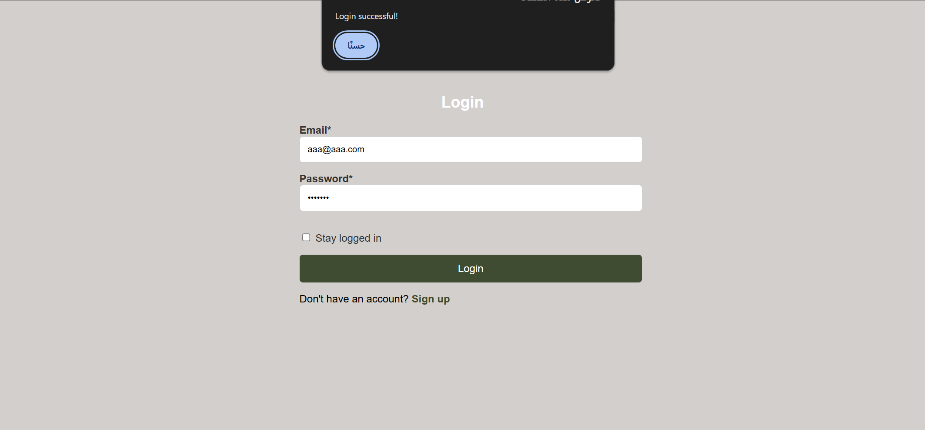

**Confirmation:**

<!DOCTYPE html>

<html>

<head>

<title>Message Sent</title>

<meta charset="UTF-8">

<style>

body, html {

height: 100%;

font-family: "Inconsolata", sans-serif;

display: flex;

background: #d2cfcc;

margin: auto;

margin-top: 11%;

}

.message {

text-align: center;

}

.w {

text-decoration: none;

color: green

}

.w:hover {

background: #a7aaa4;

padding: 4%;

border-radius: 5px;

}

</style>

</head>

<body>

<div class="message">

<h1>Thank You!</h1>

<p>Your message has reached us.</p>

<a href="main page.html" class="w" >Return to Home</a>

</div>

</body>

</html>

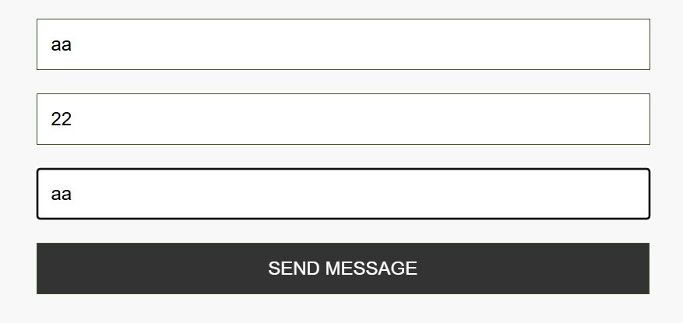

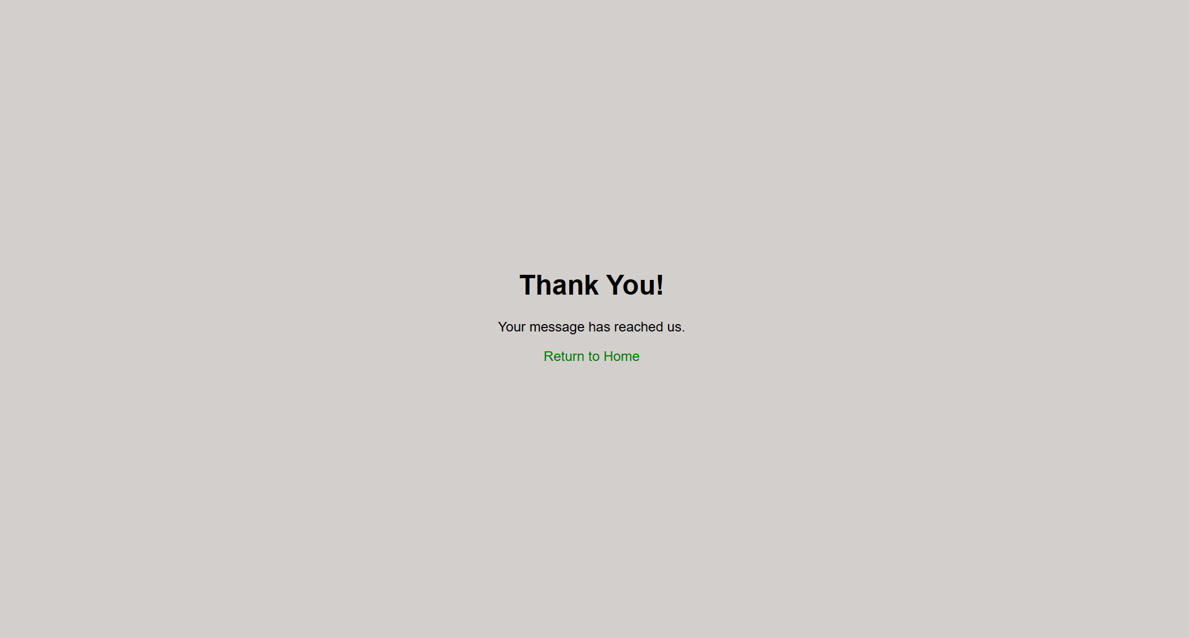

**Menu:**

<!DOCTYPE html>

<html lang="en">

<head>

    <meta charset="UTF-8">

    <title>The Menu</title>

<style>

* {

    margin: 0;

    padding: 0;

    box-sizing: border-box;

}

body {

    font-family: 'Arial', sans-serif;

    background-color: #fafafa;

    color: #333;

}

header {

    background-color:rgb(63, 76, 50 );

    color: white;

    text-align: center;

    padding: 40px 0;

}

header h1 {

    font-size: 3em;

    margin-bottom: 10px;

}

header p {

    font-size: 1.5em;

}

.a {

    padding: 30px;

    max-width: 1200px;

    margin: 0 auto;

}

.b{

    display: grid;

    grid-template-columns: repeat(auto-fit, minmax(300px, 1fr));

    gap: 20px;

}

.c {

    background: white;

    border-radius: 10px;

    box-shadow: 0 4px 8px rgba(0, 0, 0, 0.1);

    overflow: hidden;

    transition: transform 0.3s ease, box-shadow 0.3s ease;

}

.c:hover {

    transform: translateY(-5px);

    box-shadow: 0 6px 12px rgba(0, 0, 0, 0.2);

}

.menu-image {

    width: 100%;

    height: auto;

    object-fit: cover;

}

.menu-details {

    padding: 20px;

    text-align: center;

}

.menu-details h3 {

    font-size: 1.8em;

    color: #333;

    margin-bottom: 10px;

}

.menu-details p {

    font-size: 1em;

    color: #555;

    margin-bottom: 15px;

}

.price {

    font-size: 1.2em;

    color: black;

    font-weight: bold;

}

</style>

</head>

<body>

    <div class="container">

    <header >

        <h1>The Menu</h1>

    </header>

    <section class="a">

        <div class="b">

            <div class="c">

                <img src="c1.png" alt="c1" class="menu-image">

                <div class="menu-details">

                    <h3>Iced V60</h3>

                    <span class="price">$3.99</span>

                </div>

            </div>

            <div class="c">

                <img src="c2.png" alt="c2" class="menu-image">

                <div class="menu-details">

                    <h3>Namaq Cake</h3>

                    <span class="price">$4.49</span>

                </div>

            </div>

            <div class="c">

                <img src="c3.png" alt="c3" class="menu-image">

                <div class="menu-details">

                    <h3>Brownie with Ice Cream</h3>

                    <span class="price">$5.49</span>

                </div>

            </div>

            <div class="c">

                <img src="c5.png" alt="c5"  class="menu-image">

                <div class="menu-details">

                    <h3>Dulcey Cake</h3>

                    <span class="price">$7.99</span>

                </div>

            </div>

            <div class="c">

                <img src="c6.png" alt="c6" class="menu-image">

                <div class="menu-details">

                    <h3>Coffee Day Container</h3>

                    <span class="price">$8.99</span>

                </div>

            </div>

            <div class="c">

                <img src="c7.png" alt="c7" class="menu-image">

                <div class="menu-details">

                    <h3>Caramel Bites Box</h3>

                    <span class="price">$22.99</span>

                </div>

            </div>

        </div>

    </section>

    </div>

   </body>

</html>

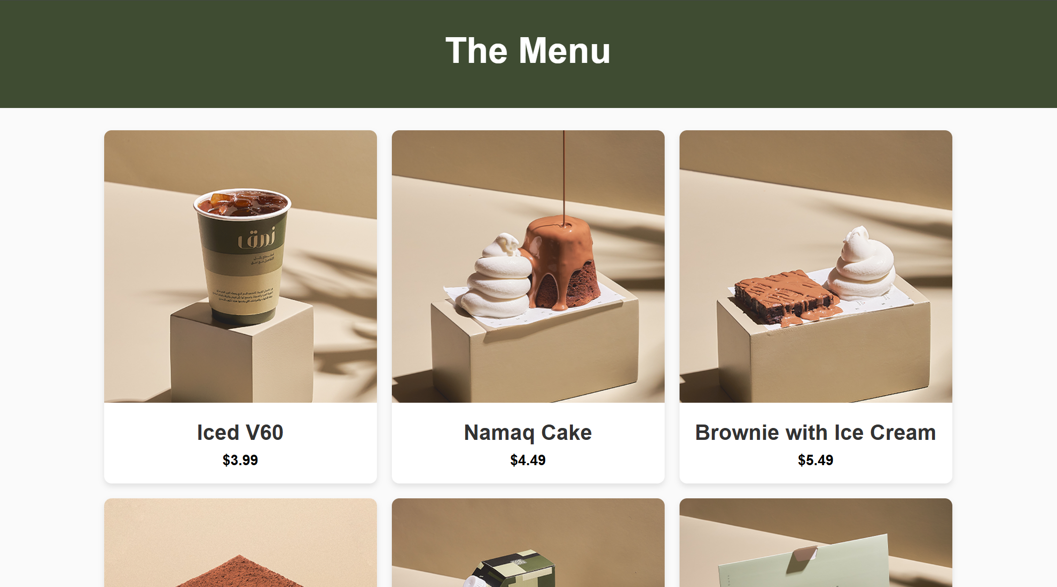

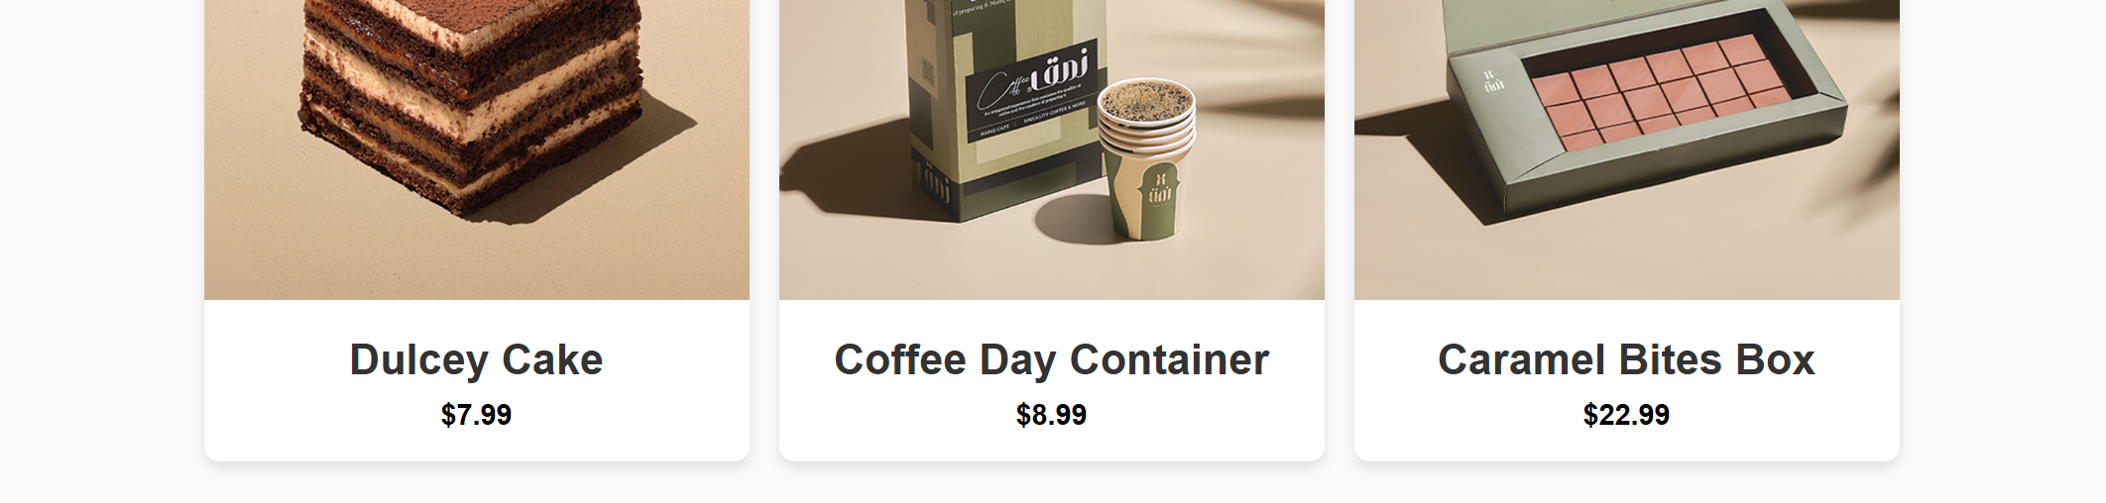

**Who we are:**

<!DOCTYPE html>

<html lang="ar">

<head>

    <meta charset="UTF-8">

    <title>Who we are</title>

    <style>

        body, html {

            height: 100%;

            margin: 0;

            font-family: "Arial", sans-serif;

            direction: rtl;

            background-image: url(v6.png);

        }

        .container {

            display: flex;

            justify-content: center;

            align-items: center;

            height: 50%;

            text-align: center;

            padding: 20px;

        }

        .content {

            background: white;

            box-shadow: 0 4px 8px rgba(0, 0, 0, 0.1);

            padding: 40px;

            max-width: 900px;

        }

        p {

            font-size: 18px;

            line-height: 1.6;

            color: #555;

        }

        header {

            background-image: url(v6.png);

        }

        h1 {

            text-align: center;

            font-size: 2.5em;

            font-family: "Arial", sans-serif;

        }

    </style>

</head>

<body>

    <header>

       <img src="v6.png" alt="v6"

       width="1430px"

       height="200px"

       >

    </header>

    <h1>Who we are</h1>

    <div class="container">

        <div class="content">

            <h2>Through our creative journey</h2>

            <p>

                We felt the need to excel in the world of coffee shops and create a different experience for the customer.

We brought the world to select the finest types of coffee crops, and we met our fathers with extensive experience to study the degrees of roasting and its secrets.

We also make sure to choose a variety of delicious sweets from different countries to ensure the customer has a distinctive taste and a unique experience

            </p>

        </div>

    </div>

</body>

</html>

